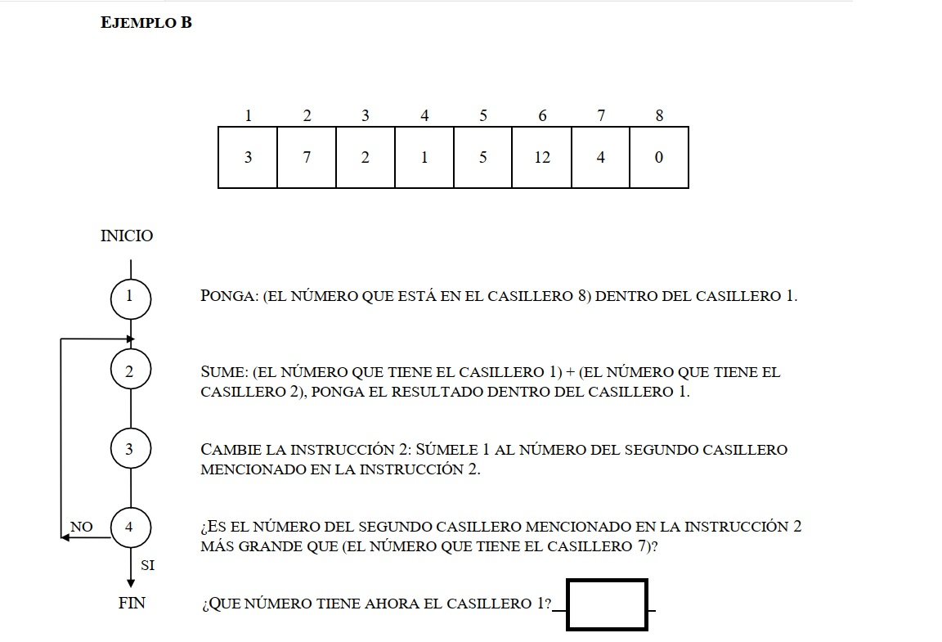

Respuesta = 8

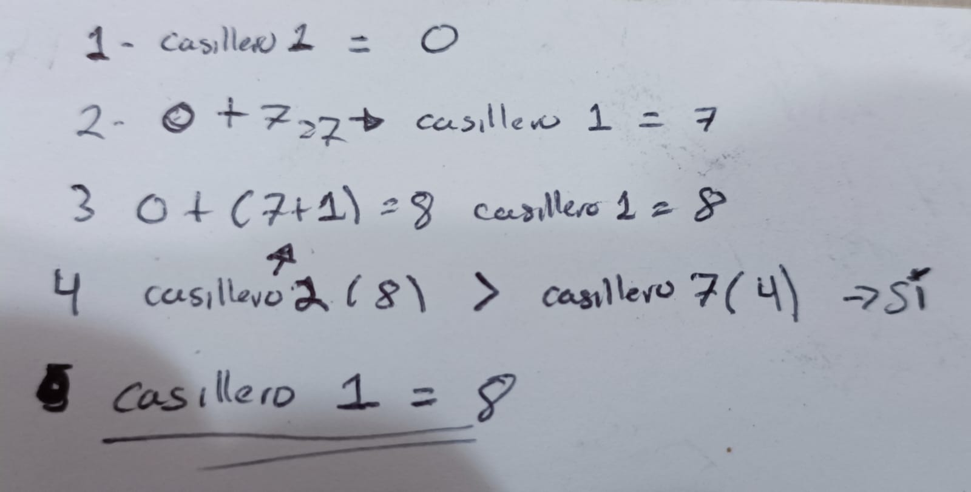

public class Main {

public static void main(String[] args) {

int[] numbers = { 3, 7, 2, 1, 5, 12, 4, 0 };

// 1 Put in the chamber 1 the number in the chamber 8

numbers[0] = numbers[7];

int temp = 1;

do{

//2 - Sum the number in the chamber 1 to the number in the chamber 2 and put the total

//in the chamber 1

numbers[0] += numbers[temp];

//3 - Change the instruction 2 adding in 1 the second number of the chamber that is mentioned in that instruction

temp++;

//4 - Is the second number in the chamber in the instruction 2 mentioned before than the number in the chamber 7?

System.out.println("Number in the chamber 1: " + numbers[0]);

} while (temp < numbers[6]);

}

}

